## UML Diagrams

### UML Use Case Diagram

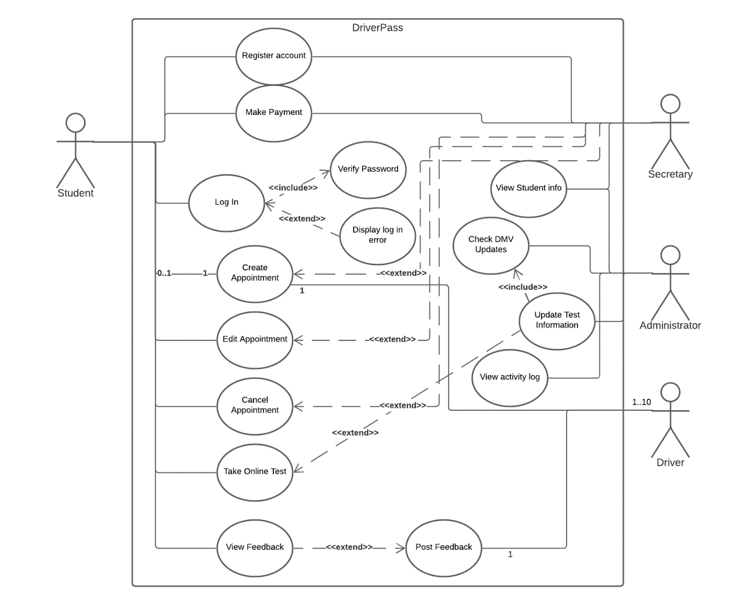

### UML Activity Diagrams

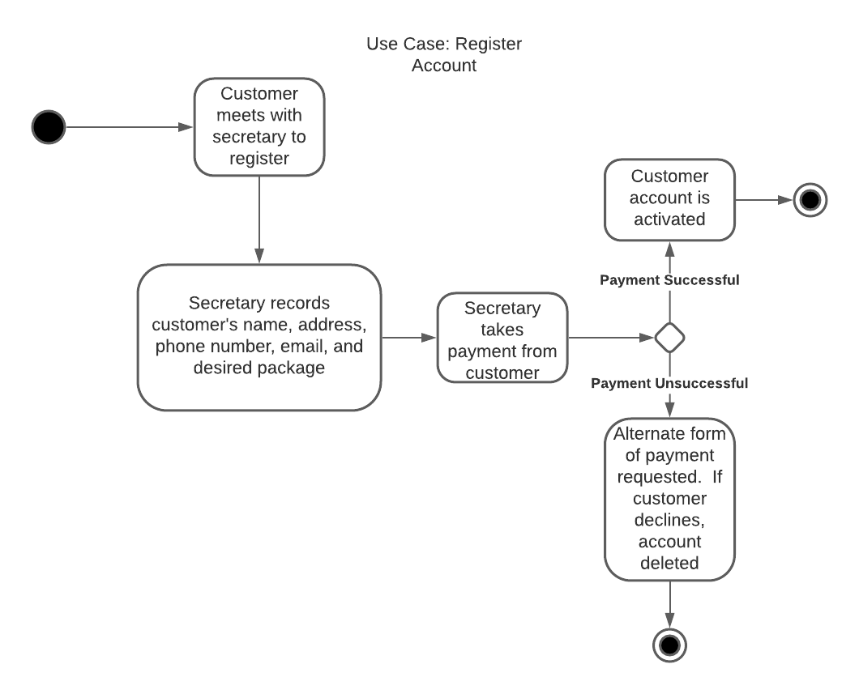

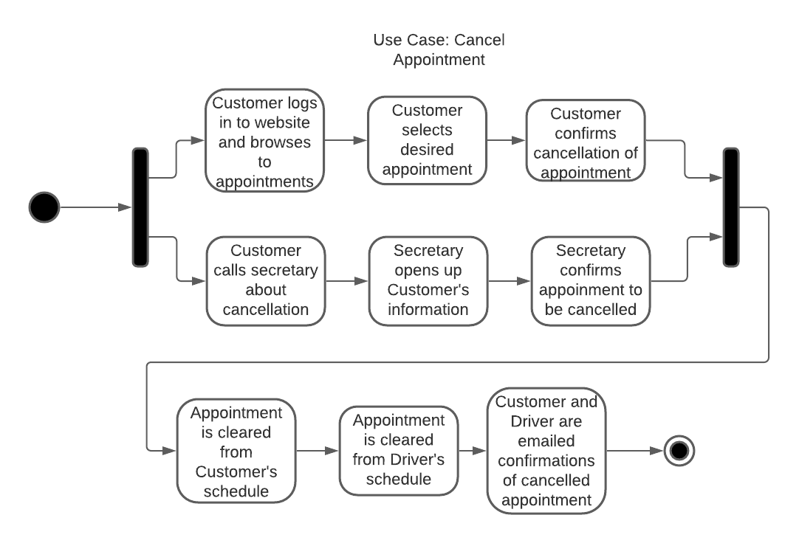

### UML Sequence Diagram

### UML Class Diagram

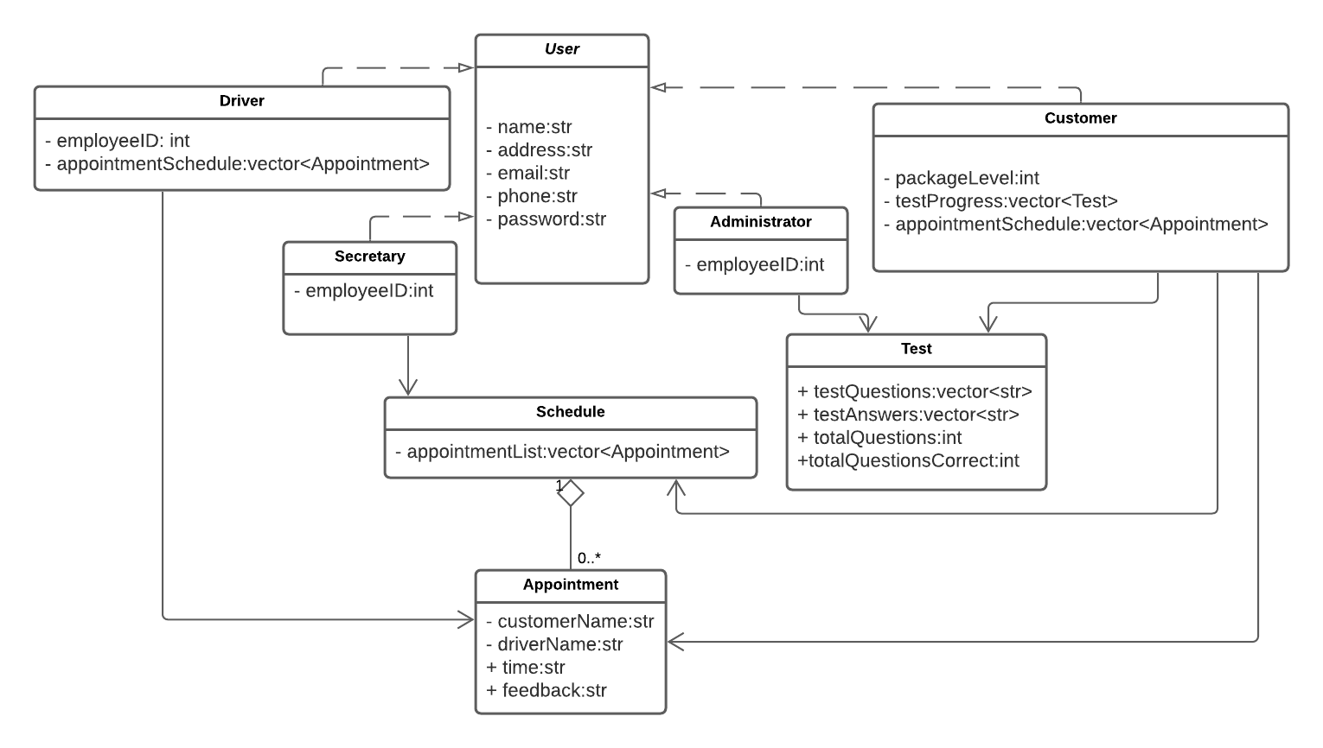

## Technical Requirements

The requirements for this system will include a cloud based web hosting platform, a database to store user information, a web application to handle both the employee and customer sides of the system, allowing customers to view their info, schedule, modify, or cancel appointments, as well as take tests. The Secretary user will have tools in the web application to view the customer database, register new customers, secure payment (card processing would be handled by an approved third party tool), and edit customer appointments. Administrators will have tools in the web app to view the customer database, view and print activity logs generated by the system, close off or enable available package tiers, reset other user passwords, and push updates to the online test system. Drivers will be able to view their schedule for the day and be able to view a picture of the customer they have an appointment with through the web app. A computer or mobile device with a web browser and an internet connection will be necessary to interact with the system. The database and web application would be hosted by the above mentioned cloud based platform, so hardware or maintenance of these aspects will not be required.